RESOLUTION NO.__________

RE: CERTIFICATE OF APPROPRIATENESS UNDER THE
PROVISIONS OF THE ACT OF THE PENNSYLVANIA
LEGISLATURE 1961, JUNE 13, P.L. 282 (53
SECTION 8004) AND BETHLEHEM ORDINANCE NO.
3952 AS AMENDED.

WHEREAS, it is proposed to replace existing door with a new pair of French doors and replace a pair of double hung windows with a smaller casement window at 46 E. Wall St.

NOW, THEREFORE, BE IT RESOLVED by the Council of the City of Bethlehem that a Certificate of Appropriateness is hereby granted for the proposal.

Sponsored by: (s)

(s)

ADOPTED BY COUNCIL THIS DAY OF

(s)
President of Council

ATTEST:

(s)
City Clerk

HISTORICAL & ARCHITECTURAL REVIEW BOARD

APPLICATION #3: The applicant proposes to replace the door with a new pair of aluminum
clad full light French doors & replace a pair of double hung windows at
46 E. Wall St.

OWNER: Ann Gastinger
46 E. Wall St., Bethlehem, PA 18018
__________________________________________________________________

The Board upon motion by Marsha Fritz and seconded by Connie Glagola adopted the proposal that City Council issue a Certificate of Appropriateness for the following:

- Install new pair of aluminum clad full light French doors.

2. Replace existing pair of double hung windows with smaller casement windows.

3. French door and new window will have a white exterior clad finish as well as
patching and infilling the existing aluminum siding.

4. The motion was unanimously approved.

__________________________________________________________________________

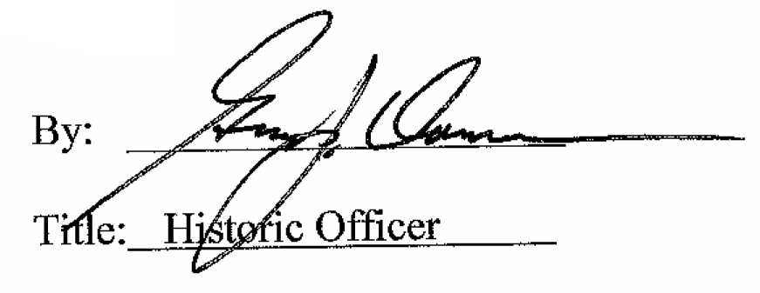

Date of Meeting: November 5, 2014

